MIS602 Data Modeling & Database Design

Name

Institutional Affiliation

Contents

SQL Output 3

Tasks Output 3

Task 1 3

Task 2 5

Task 3 5

Task 4 5

Task 5 6

Task 6 6

Task 7 6

Task 8 7

Task 9 7

Task 10 7

Task 11 8

Task 12 8

Task 13 8

Task 14 9

Task 15 9

Task 16 10

Task 17 10

Task 18 10

Task 19 11

Task 20 11

Task 21 11

Task 22 11

Task 23 12

Task 24 12

# SQL Output

The figures below represent the output of running the various SQL statements and commands

# Tasks Output

## Task 1

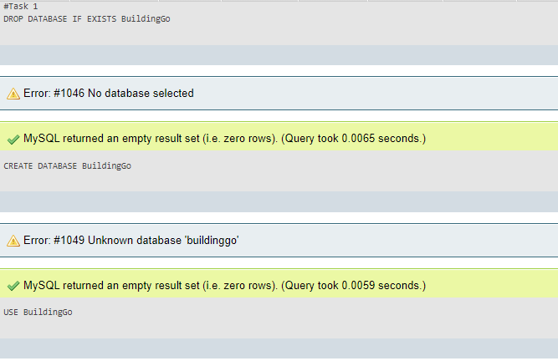

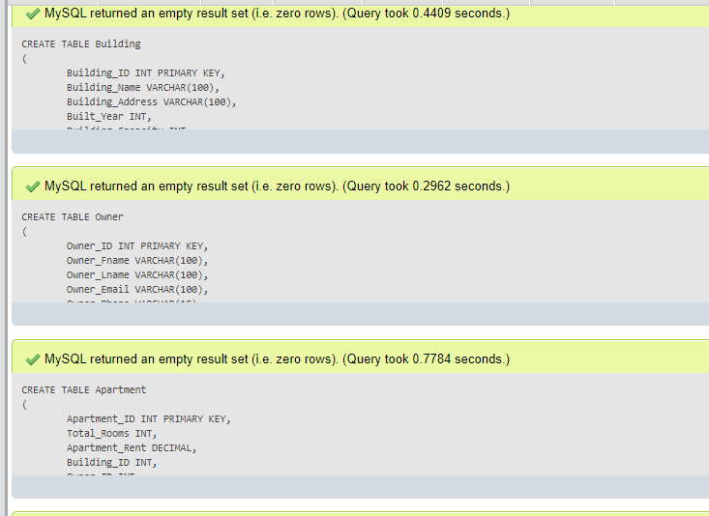

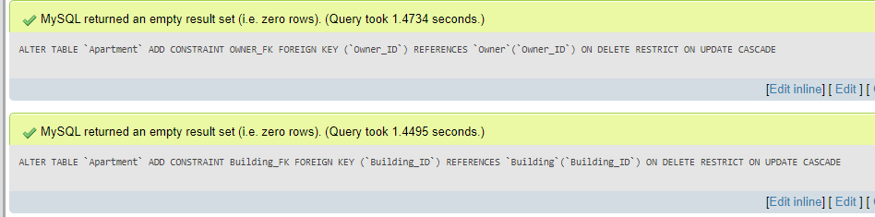

## Task 2

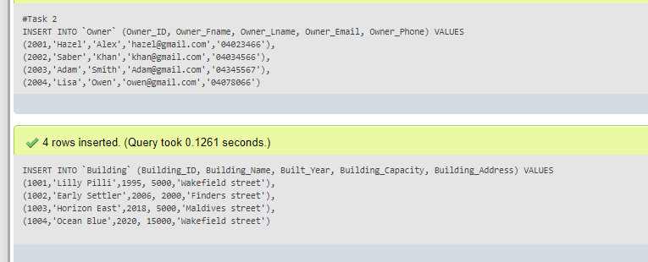

## Task 3

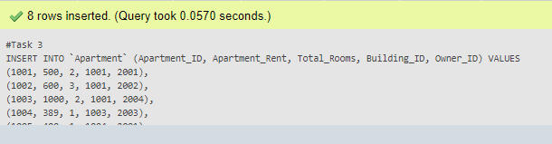

## Task 4

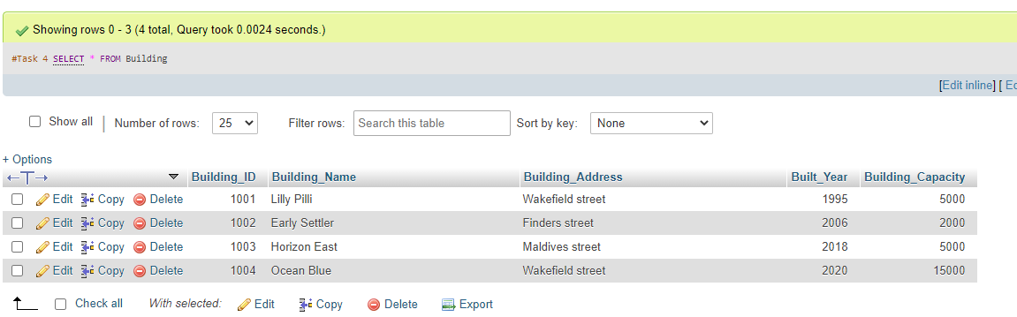

## Task 5

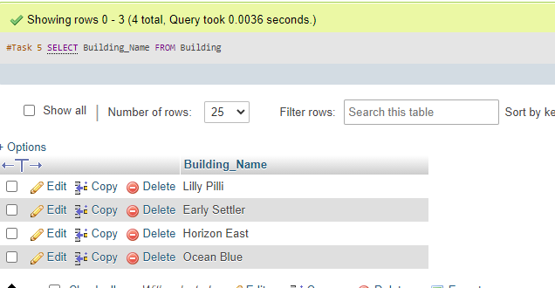

## Task 6

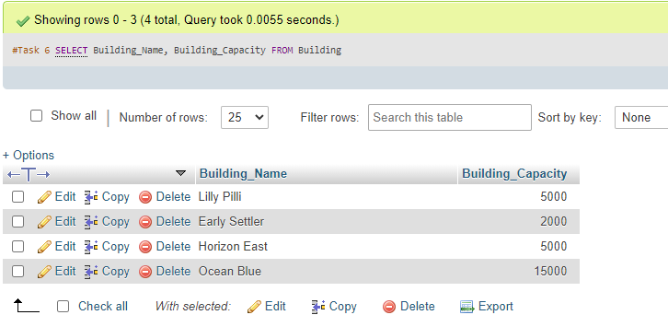

## Task 7

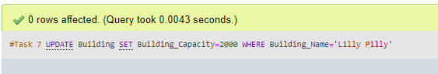

## Task 8

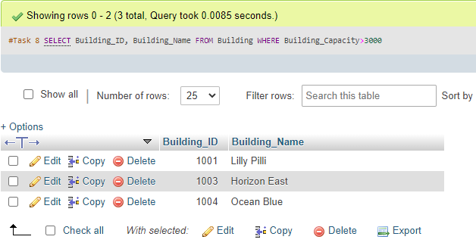

## Task 9

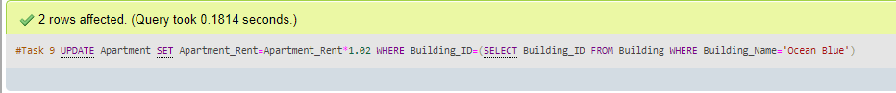

## Task 10

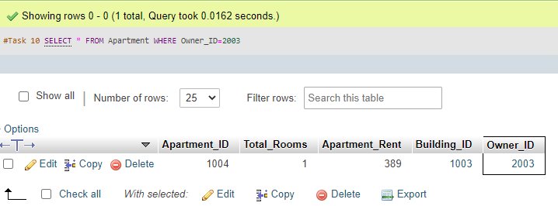

## Task 11

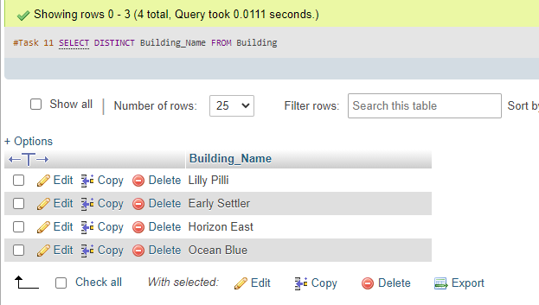

## Task 12

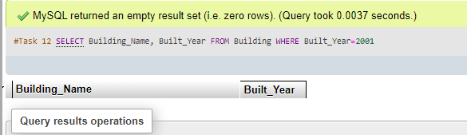

## Task 13

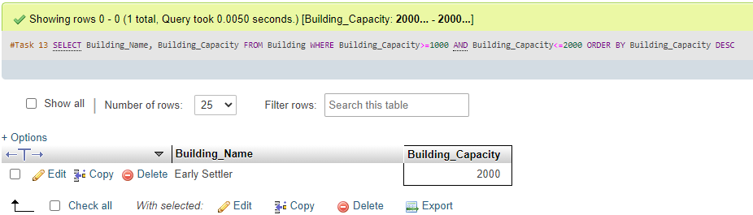

## Task 14

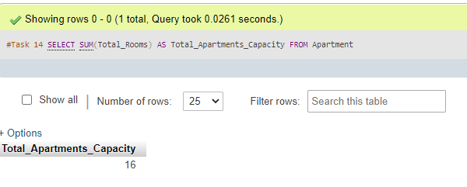

## Task 15

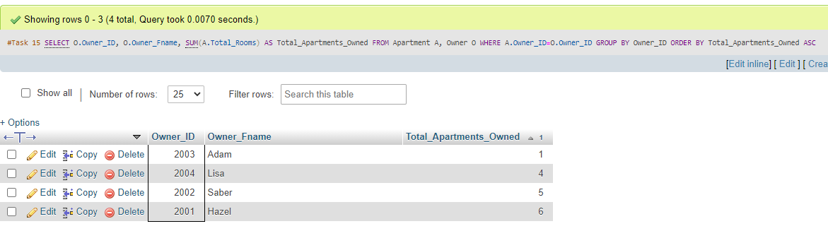

## Task 16

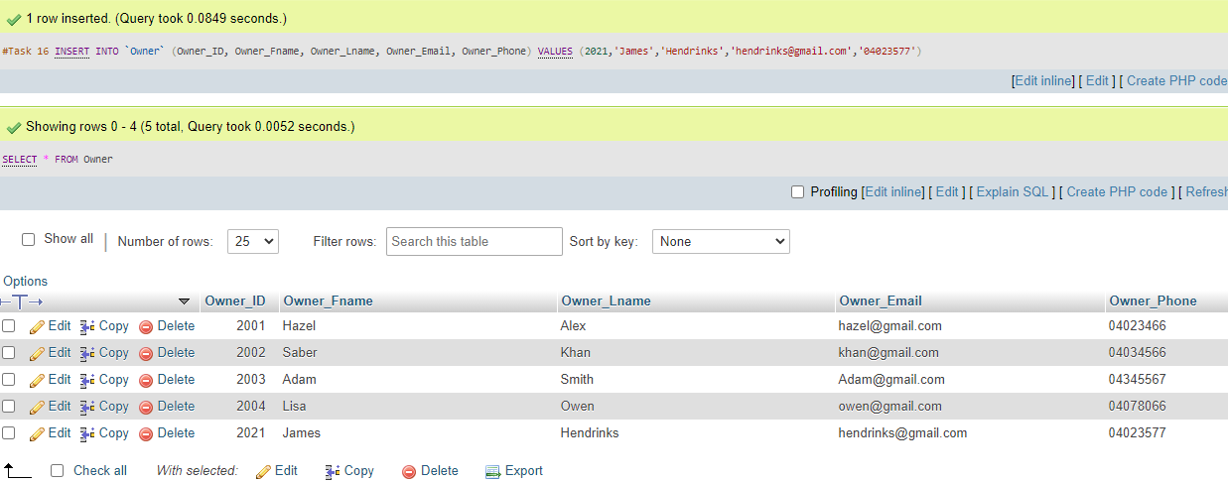 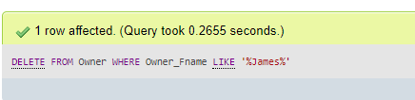

## Task 17

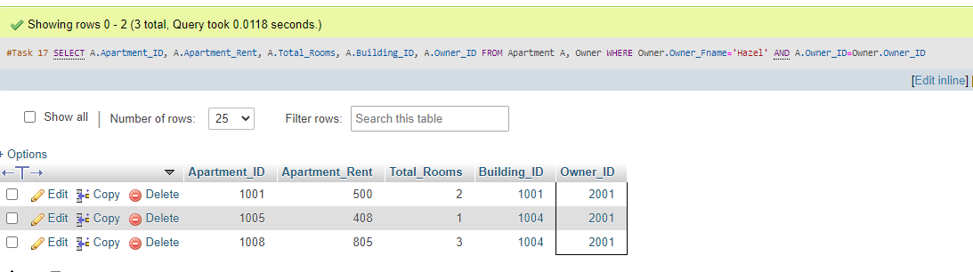

## Task 18

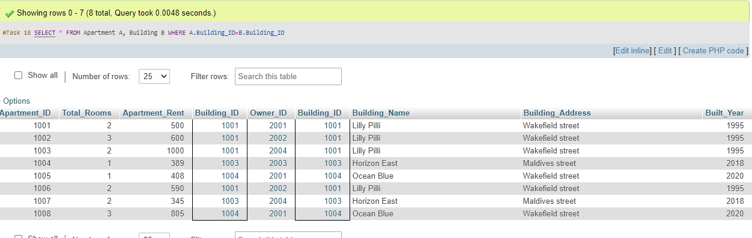

## Task 19

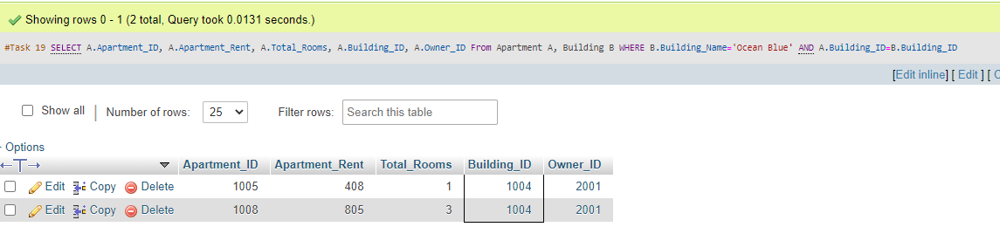

## Task 20

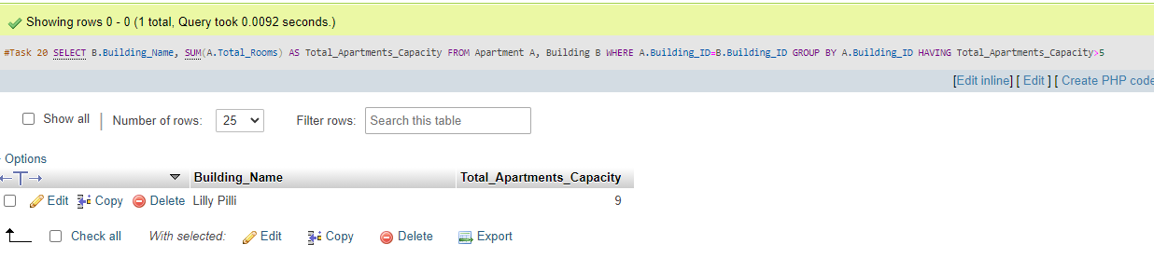

## Task 21

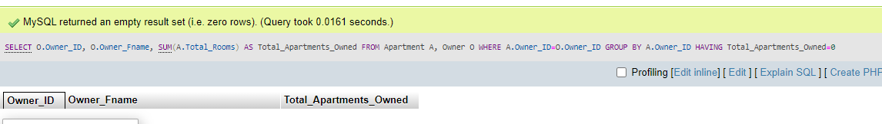

## Task 22

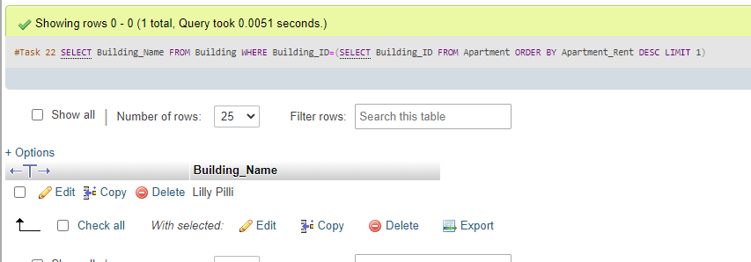

## Task 23

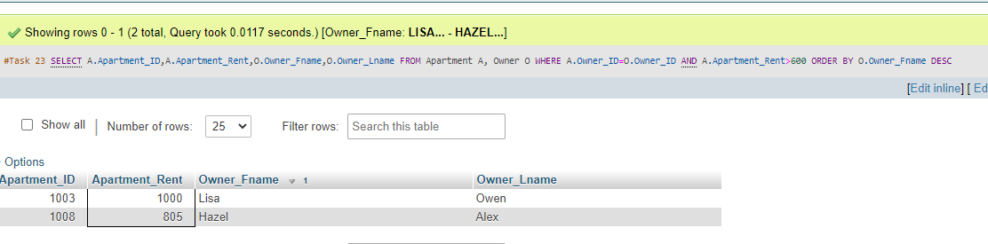

## Task 24

